Jakob Kovar

Jk2vt

02/21/2022

Lab 3

Dim_customers

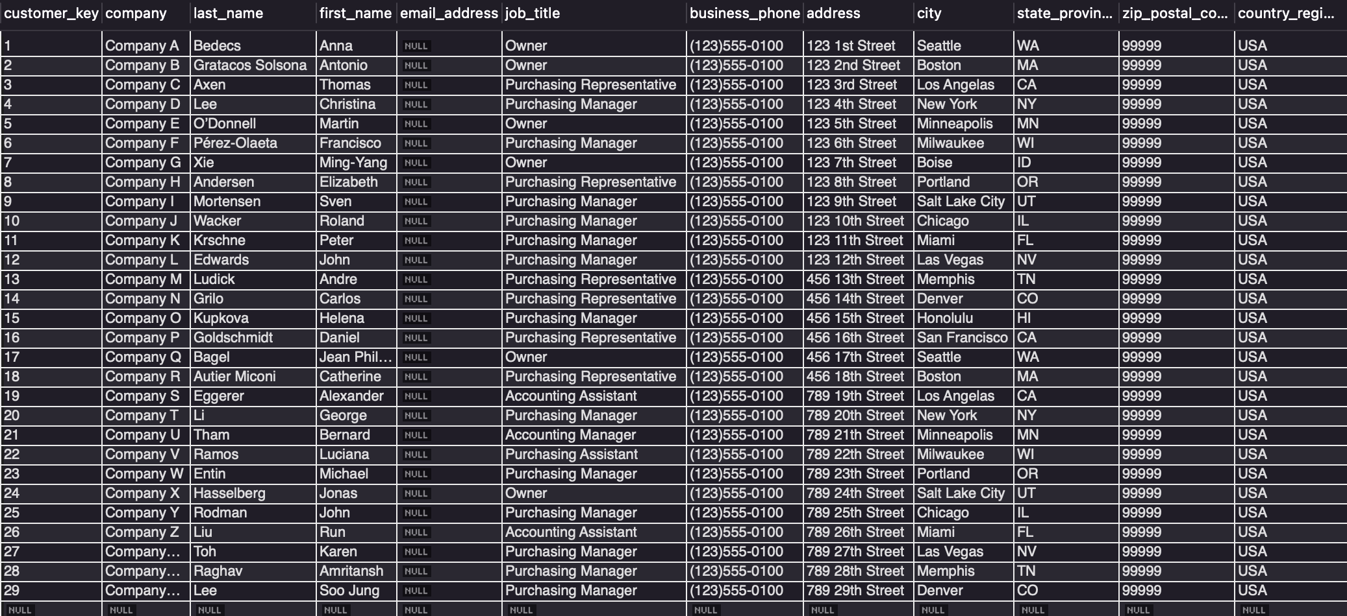

Dim_employees

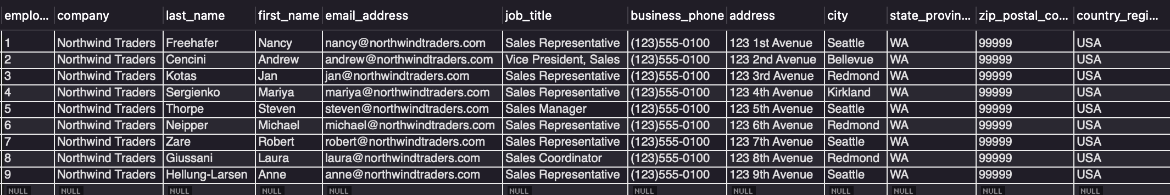

Dim_products

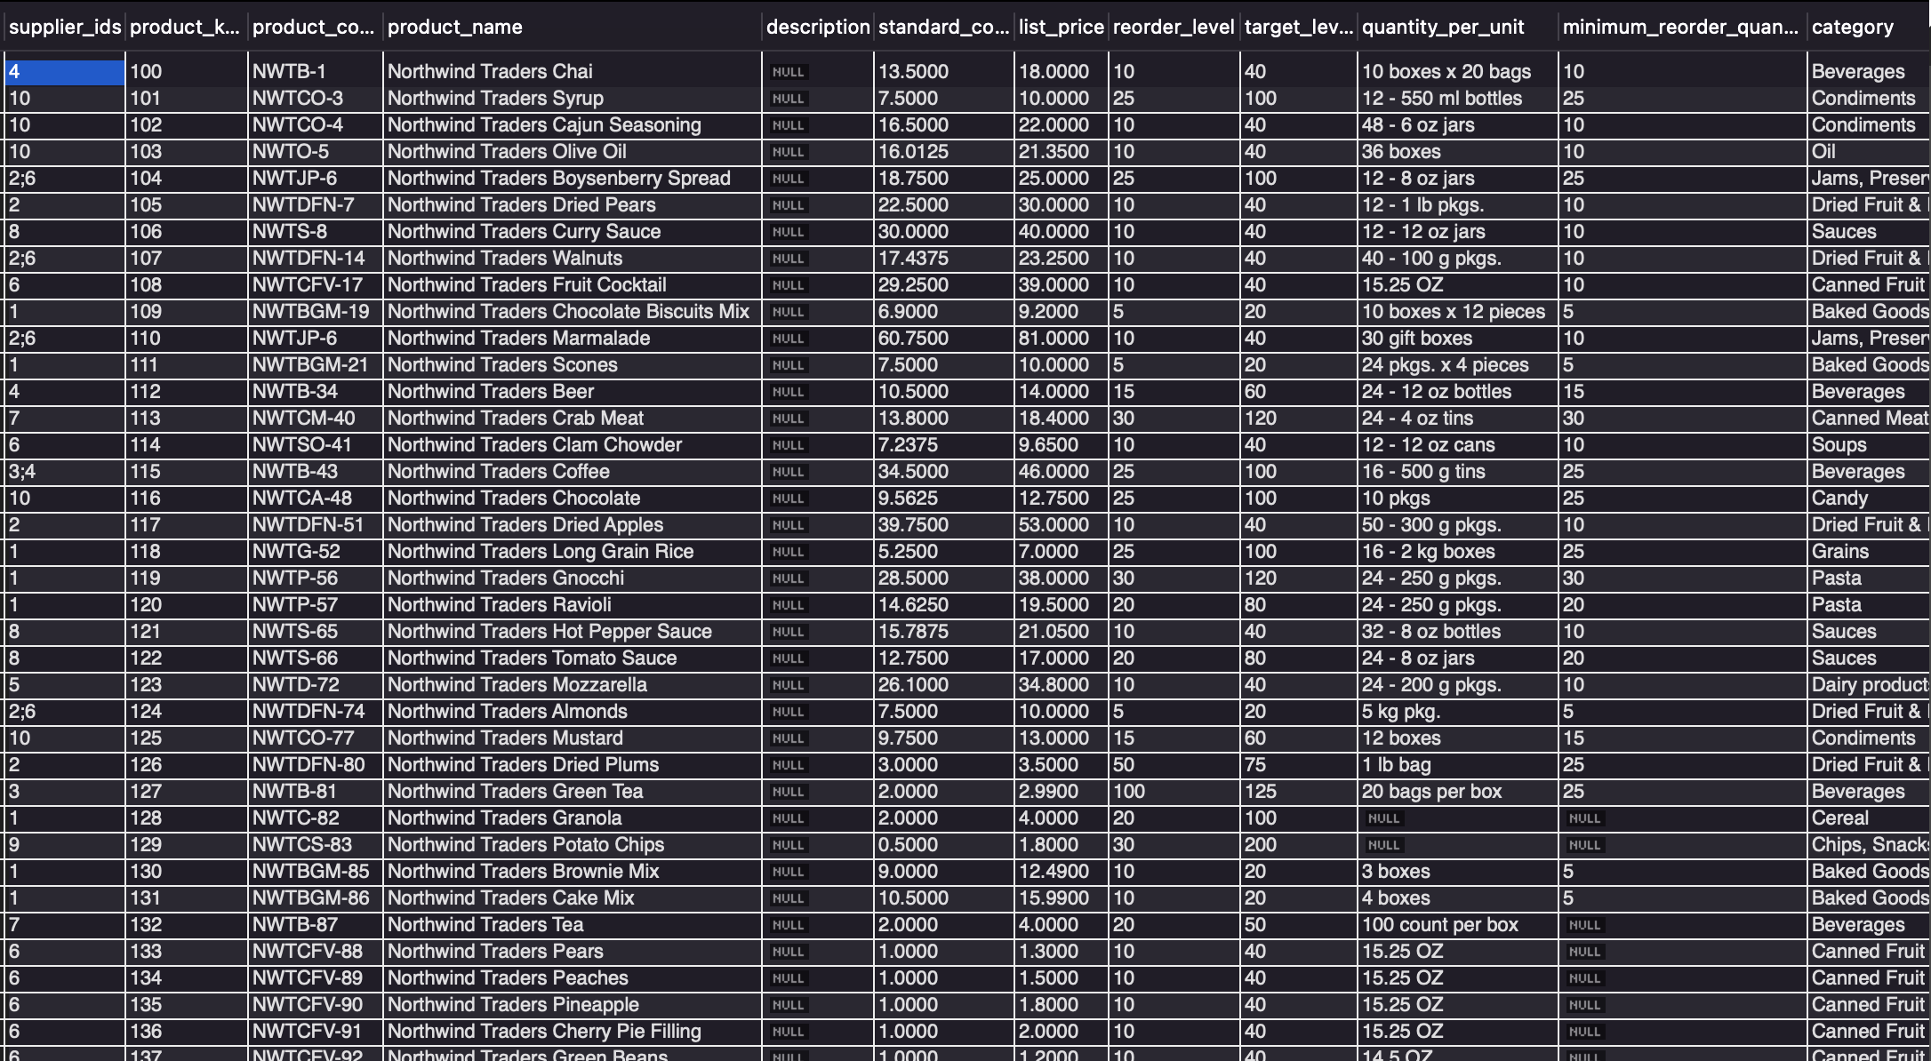

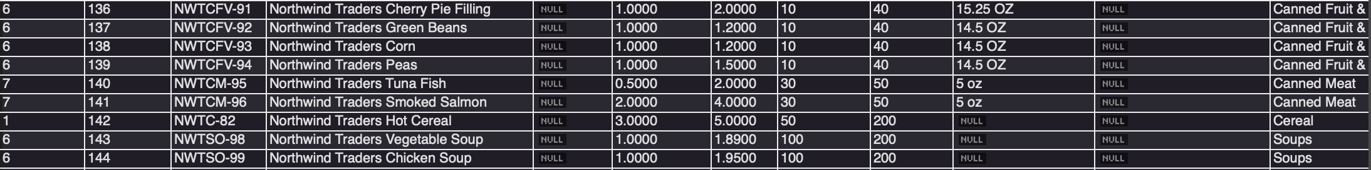

Dim_shippers

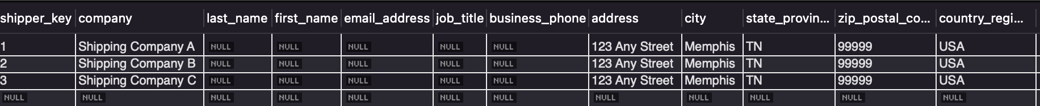

Fact_orders

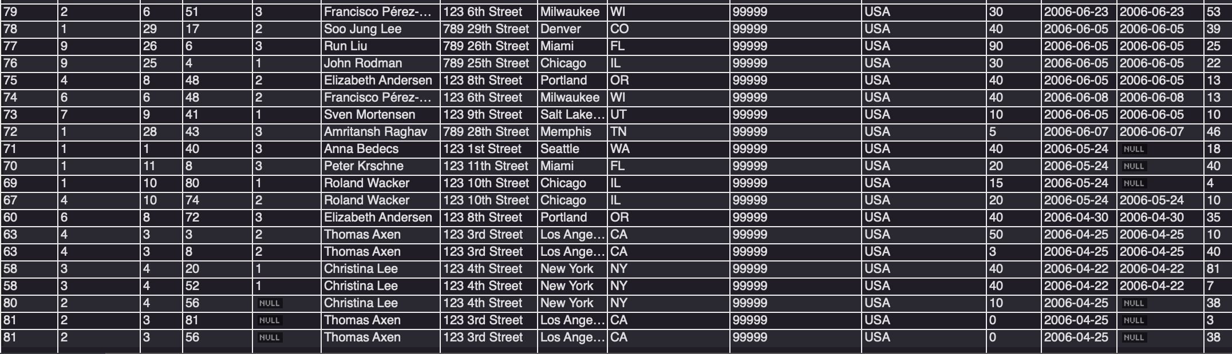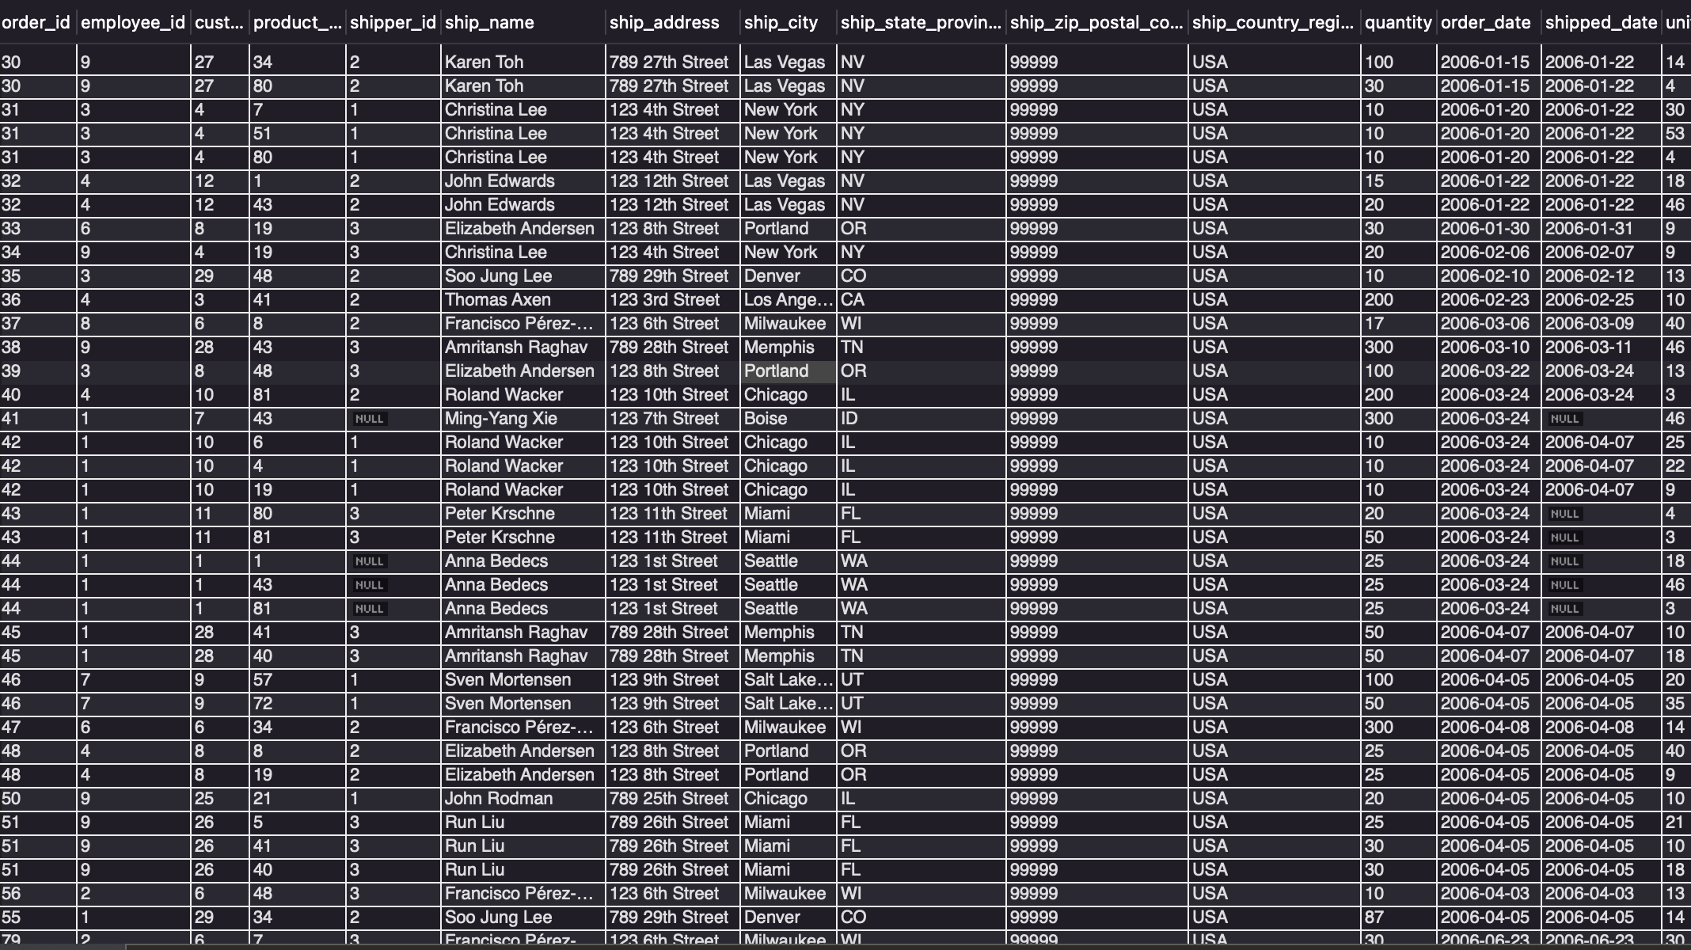

Summary Table:

